The Eurozone Sovereign Debt Crisis and its effect on the Eurozone
Recently, various member states of the European Union that use the Euro have been experiencing sovereign debt crises, particularly member states in the periphery of the Eurozone, in this case, Greece, Italy, Ireland, Portugal, and Spain. These debt crises are caused by consistently high budget deficits, consistently high overall public debts, and, in some cases, both. The Euro was created to harmonize the financial and monetary systems of the member states of the European Union. Financial and monetary harmonization is accomplished by imposing a standardized monetary policy across Europe, with a standard interest rate regime and a standard inflation target. The states that adopted the Euro are part of the Eurozone and their national central banks are part of the Euro system and take directions from the European Central Bank in Frankfurt. However, economic troubles and economic mismanagement in certain countries, especially in peripheral and southern Europe, threatens to undo the above-mentioned monetary union.
Member states of the Eurozone share a common currency with a common interest rate, enabling states to borrow regardless of the financial situation of the state concerned. For instance, Portugal, Italy, and Greece are able to issue bonds with interest rates that are typical in states like Germany and Austria. Thanks to their inclusion in the Euro, Ireland and southern European countries were able to borrow large amounts of money to finance their respective economic booms.
Joining the Eurozone
One important part of the European Union is the Euro currency, governed by the European Central Bank in Frankfurt. Countries that use the Euro are colloquially and collectively known as the Eurozone. To harmonize (or at least to attempt to do so) the divergent economies in the area, there are certain requirements that members must abide by before being eligible to adopt the Euro as their national currency. These requirements are generally known as the Maastricht convergence criteria, implemented when the EU had 15 members. Keep in mind that all of the countries that are currently affected by the sovereign debt crisis were members of the European Union at the time the criteria were implemented.
However, with a common currency comes a common central bank, and thus, a common monetary policy with uniform interest rates. Members are also held to a common budget deficit limit of 3 percent as enumerated in the Maastricht convergence criteria. In other words, no Eurozone member can have a budget deficit of more than 3 percent over one fiscal year. In addition, no Eurozone member is allowed to have a public (i. e. government) debt burden in excess of 60 percent of that state’s Gross Domestic Product. Other criteria for inclusion include low inflation, low sovereign debt interest rates, and a stable exchange rate between the national currency and the Euro. In this case, a country’s inflation cannot be in excess of 1.5 percent of the average of the three EU members with the greatest price stability. Also, long-term interest rates cannot exceed 2 percent of the average of the three EU members with the greatest price stability. Furthermore, the exchange rate of the national currency (at the time the EU member state applies for membership in the Eurozone) cannot deviate more than 15 percent from the Euro in either direction.
The Party Starts (and goes on) at Club Med
Historically, the “Club Med” countries were poorer and lesser developed than their counterparts in northern Europe. “Club Med” is a designation by economists of the European Union members along the Mediterranean Sea. These countries are Greece, Italy, Portugal, and Spain, and if combined into an acronym, they would be known as the “GIPS” countries. These countries “developed very differently from the industrial powerhouses of northern Europe” such as the United Kingdom, Germany, and France. Thanks to their inclusion in the Eurozone, they were able to grow their economies and catch up to northern European levels of prosperity, or so it seems.
It turned out that the Spanish economic boom was powered by a debt-fueled property bubble and was effectively a mirage. Typically in a booming national economy, there is substantial physical evidence with goods from that country appearing on store shelves and in showrooms throughout the world, for example, in West Germany during the Wirtschaftswunder and in South Korea during its economic boom. However, that was not the case in Spain, which did not launch any new products, although some non-industrial brands became known throughout the world.
As it turned out, property prices increased 80 percent between 1990 and 2009, leading to the introduction of 50-year mortgages, with such loans being issued under relatively relaxed lending criteria. Since the Euro was launched, total debt levels in Spain effectively doubled from 193 percent of GDP in 2000 to 366 percent of GDP in 2008. Average household debt levels
increased at a similar rate, from 69 percent of disposable income in 2000 to 130 percent of disposable income in 2008, an increase of 88 percent. This is compared to a 33 percent increase in the United States, a 52 percent increase in Great Britain, and a decrease in Germany during the same time period. Effectively, the modern Spanish economic miracle was based on debt, not production. A similar phenomenon took place in Greece, Ireland (debt relative to GDP was 700 percent in 2008), Portugal, and to a lesser extent Italy.
It also turns out that, despite being in the Eurozone, the economies of the southern European member-states are not as competitive as their northern European counterparts. As pointed out by the Organization for Economic Co-operation and Development, the Spanish economy was effectively stuck in the past. Its labor laws were outdated and restrictive, there were significant planning restrictions, and the presence of cartels precluded industries from being competitive. Membership in a common currency system, in which states with less competitive economies use the same currency as more competitive economies, leads to one-size-fits-all approach, in which all member states are treated the same without regard to actual economic conditions or economic fundamentals prevalent in that particular member state.
The Crisis Begins in Earnest
The sovereign debt crisis in the Eurozone started when various peripheral Eurozone nations incur unusually high budget deficits relative to their Gross Domestic Product. First to fall
was Greece, as “it was in Athens that the debts started falling due,” after Standard and Poors placed Greece’s A- long term credit rating on a negative watch list. High budget deficits and the
highest overall debt load in the Eurozone at the time at 125 percent of GDP called into question the ability of Greece to pay its debts, triggering much higher interest rates demanded by purchasers of bonds issued by the Greek government. The following table illustrates the spreads of various Eurozone government bonds over bonds issued by the German government. The spread is the interest differential between the target country (for instance, Greece) and the reference country (in this case, Germany). As illustrated in the following table, as of December 2010, 10-year Greek government bonds carry a spread of around 9 percent over Bunds, or 10-year German government bonds. Thus, when Greece issues a bond, investors demand 9 percentage points above what they demand for investing in Bunds. For Irish bonds, the interest rate spread is 6 percentage points, Portuguese bonds carry a 4 percentage point interest premium over German Bund Bonds. Although the bonds issued by the above countries are denominated in Euros, the higher interest demanded is a measure of the higher risk of default, and thus a lower creditworthiness rating, by Greece, Ireland, and Portugal than Germany.
Figure 2 shows the budget deficits and relative public debt burdens to Gross Domestic Product of OECD member states in 2010. These figures are used to gauge the creditworthiness of national governments. A country with a high budget deficit and a high public debt burden is generally regarded as on shaky financial ground, and therefore, less credit-worthy than a country with a low budget deficit and public debt. The creditworthiness of these countries is reflected in their long term sovereign debt ratings (credit ratings) issued by Moody’s, S&P, and Fitch rating
agencies as shown in the table noted as Figure 4. When reading the debt ratings chart, it is important to note that “AAA” ratings represent a prime risk, “AA” ratings are very good (high grade), an “A” rating represents a good risk, and a “BAA” (Moody’s) or BBB (S&P and Fitch) rating represents a fair, but acceptable investment risk. Lower ratings are indicative of junk bond status and are thus not suitable for investment. As a result, the more financially troubled country has to pay more for the ability to issue bonds (that is, to borrow money) on international markets.
(Figure 1)
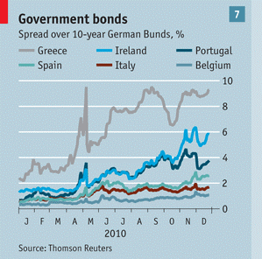
(Figure 2)
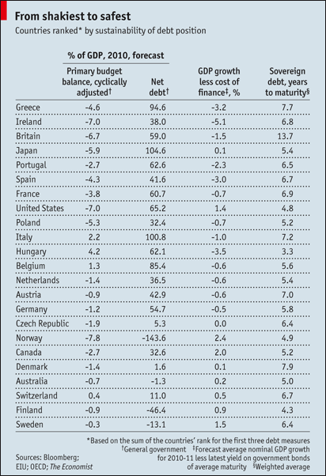
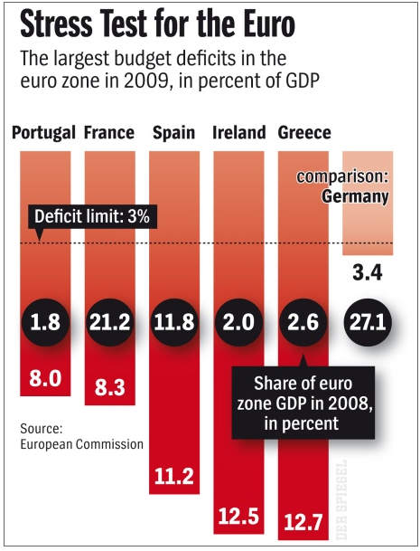
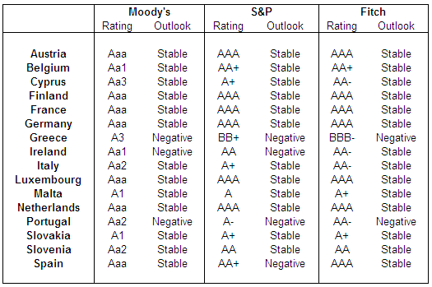
(Figure 4)
What is the fate of the Common Currency?
Greece was the first member state to be affected by the Eurozone sovereign debt crisis. From Greece, the contagion soon spread through the rest of the Club Med countries and then on to Ireland, which suffered a sudden burst of the property bubble. There are three possibilities for the Euro, the latter two possibilities being far-fetched until the onset of the crisis. The first possibility is that the Euro will survive intact, which is the best-case scenario among enthusiasts of European monetary integration. However, this will require austerity measures or bailouts of troubled governments, in which the latter is highly contested in the more fiscally-responsible countries such as Germany and the Netherlands, which are highly averse to inflating the Euro and thus compromising the value of the currency. In fact, per a poll of public opinion in the German tabloid Bild, four out of five Germans opposed ANY bailout for Greece and 53 percent favored Greece’s expulsion from the Eurozone. Similar sentiments made it to the Netherlands as well.
The second possibility is the split of the Euro into two distinct currencies, the “Northern Euro” and the “Southern Euro.” Countries that would use the Northern Euro would be Finland, Austria, the Netherlands, Germany, Luxembourg, and possibly Belgium and France. These countries, especially Germany, favor an anti-inflationary monetary policy, due to Germany being twice affected by hyperinflation, once during the Weimar period and the second time immediately after World War II. In other words, they believe in dear money, not easy money or cheap money. On the other hand, the “Southern Euro” would be composed of Portugal, Italy, Greece, Spain, and possibly Belgium and France (Belgium is in northern Europe, but its fiscal situation is closer to that of many southern European countries). The likely result of this scenario is that the “Northern Euro” will be considerably more valuable than the “Southern Euro.” Thus, the economies of the southern Eurozone states would be more competitive as their exports will be more competitive internationally. Conversely, exports from the northern Eurozone states would be considerably more expensive but at least they will not be exposed to higher fiscal risks.
The third scenario is the partial or full breakup of the Euro into the respective national currencies. This has been predicted by numerous analysts including Christopher Smallwood and Nouriel Roubini. For instance, Greece would revert to the drachmae, Italy would revert to the lira, and Germany would revert to the Deutschmark. In a partial breakup, the Euro and Eurozone would still be in existence, but with fewer members. This can be accomplished either by members choosing to leave or members removed from the Eurozone at the insistence of more powerful members, i. e. Germany, for repeated failure to adhere to the Maastricht convergence criteria. However, in a full breakup, the Eurozone would completely break up and all member states that use the Euro will revert to their former national currencies as illustrated before.
Based on the economic fundamentals in the peripheral Eurozone countries (such as Greece, Portugal, and Spain) versus those in the core Eurozone countries (like France, Germany,
and the Netherlands), either the second or third scenario would take place in the future. This is because the introduction of the Euro has made the economies of the peripheral member states less competitive due to higher costs. In addition, many core Eurozone states resent having to extend significant bailouts and other subsidies to peripheral states regarded as irresponsible with their finances.

WORKS CITED
-----. 2010. “A Year in Nine Pictures.” The Economist. December 29, 2010
-----. 2010. “Analysis: Thinking the unthinkable – a euro zone breakup.” http://www.cnbc.com/id/40371286/Analysis_Thinking_the_unthinkable_a_euro_zone_breakup. November 26, 2010.
-----. 2010. “Eurozone Long Term Sovereign Debt Ratings.” http://www.paddypowertrader.com/blog/index.php/views-opinions/eurozone-long-term-sovereign-debt-ratings, April 28, 2010.
-----. 2010. “Not so risk-free.” The Economist. February 11, 2010. http://www.economist.com/node/15498265?story_id=15498265
-----. 2010. “Zero Chance of Euro Zone Break Up: EU Official” http://www.cnbc.com/id/40367959/Zero_Chance_of_Euro_Zone_Break_Up_EU_Official. November 25, 2010
Angelov, Georgi. 2006. “How to Gate-Crash the Eurozone.” Europe’s World. National Bureau of Economic Research. http://www.nber.org/~wbuiter/angelov.pdf
Lynn, Matthew. 2011. Bust: Greece, the Euro, and the Sovereign Debt Crisis. Hoboken, NJ: John Wiley and Sons: 59.
Schultz, Stefan. 2010. “Five Threats to the Common Currency.” Spiegel Online. http://www.spiegel.de/international/europe/0,1518,677214,00.html

Angelov, Georgi. 2006. “How to Gate-Crash the Eurozone.” Europe’s World. National Bureau of Economic Research. http://www.nber.org/~wbuiter/angelov.pdf
Ibid., 82.
Formerly known as the “PIGS” countries (Portugal, Italy/Ireland, Greece, and Spain).
Lynn, Matthew. 2011. Bust: Greece, the Euro, and the Sovereign Debt Crisis. Hoboken, NJ: John Wiley and Sons: 59.
German for “Economic miracle.”
However, none of these brands were industrial concerns. The brands mentioned in Bust are Banco Santander (Finance) and Zara (Fashion). See Lynn, 61.
Lynn, 69.
OECD
Lynn, 61.
Ibid., 74.
Ibid., 127. Figure current as of 2009.
-----. 2010. “A Year in Nine Pictures.” The Economist. December 29, 2010
-----. 2010. “Not so risk-free.” The Economist. February 11, 2010. http://www.economist.com/node/15498265?story_id=15498265
Schultz, Stefan. 2010. “Five Threats to the Common Currency.” Spiegel Online. http://www.spiegel.de/international/europe/0,1518,677214,00.html
-----. 2010. “Eurozone Long Term Sovereign Debt Ratings.” http://www.paddypowertrader.com/blog/index.php/views-opinions/eurozone-long-term-sovereign-debt-ratings, April 28, 2010.
-----. 2010. “Zero Chance of Euro Zone Break Up: EU Official” http://www.cnbc.com/id/40367959/Zero_Chance_of_Euro_Zone_Break_Up_EU_Official. November 25, 2010
Lynn, 138.
See Figures 1 and 2 in previous pages.
-----. 2010. “Analysis: Thinking the unthinkable – a euro zone breakup.” http://www.cnbc.com/id/40371286/Analysis_Thinking_the_unthinkable_a_euro_zone_breakup. November 26, 2010.

